**Practical Work Experience and Portfolio Building**

**Evidence Reporting Document**

* **Introduction**

*The main goal of this document is to keep track of the practical hands-on work experience and lab challenges you will complete throughout the program. By doing so, at the end of the program, you will have a great portfolio that you can use for evidence of your practical skills, and you can also come back for review whenever needed. This evidence is essential in the long run and keeps you on track with the time you will spend on your career upgrade process. These notes will also play a vital role in identifying the skills and tools to reflect on your marketing materials like your CV/resume or LinkedIn Page.*

* **General Details**

**Date: 17 May 2024**

**Your Name: LOK HIM TAM (Himson)**

**Email-address:** himsom0528@gmail.com

**Name of the Challenge:** Enable Database Auditing with Azure SQL Database [Guided]

**Access Details (URL or source):** AZ500

**Details of the Challenge:**

In this lab I have working following exercise:

* Created an Azure SQL Database.
  + Create an Azure SQL Database
  + Log in to the **db41229353** database as AzureAdmin using AzPwd41229353! as the password, and then create a query to retrieve all of the rows in the SalesLT.Customer table.
* Enabled database auditing.
  + Enable SQL auditing on the **db41229353** database, and then store the audit log in in a new storage account named sa41229353 in the challenge subscription by using the default settings.
  + created a storage account
* Tested database auditing.
  + Create a database user named user1 in the database by using AzPwd41229353! as the password, and then add the new user to the db_datareader database role.
  + Create a query that selects all of the data in the SalesLT.Customer table, and then run the query.
  + Attempt to delete all of the rows from the table, and then review the error message.
  + 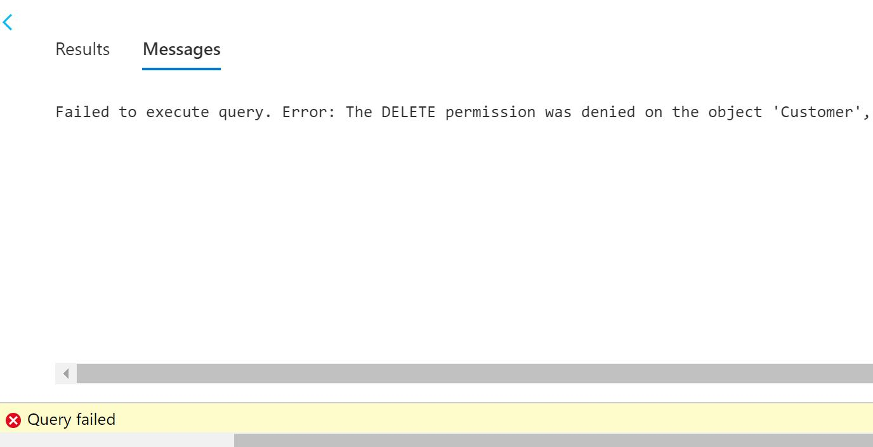
  + Review the database-level audit log for the **db41229353** database, and then review the audit of the failed delete statement.
  + 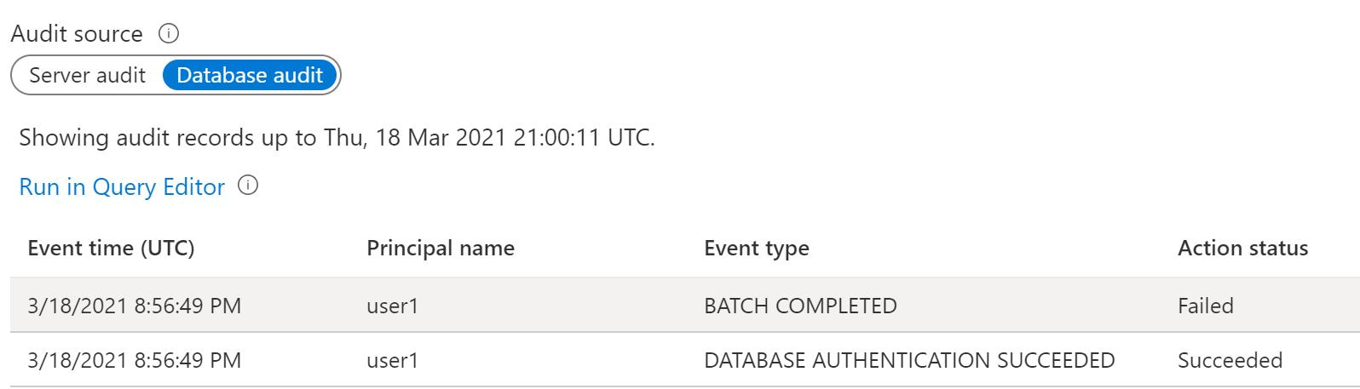

**Lab Topology**

Create an Azure SQL Database on a new logical SQL server by using the values in the following table. For any property that is not specified, use the default value.

| **Property** | **Value** |
| --- | --- |
| Resource group | **corp-datalod41229353** |
| Database name | db41229353 |
| Server name | sql41229353 |
| Server admin login | AzureAdmin |
| Password | AzPwd41229353! |
| Compute + storage | **Standard S0** |
| DTUs | **10 (S0)** |
| Data max size | **250 GB** |
| Connectivity method | **Public endpoint** |
| Allow Azure services and resources to access this server | **Yes** |
| Add current client IP address | **Yes** |
| Enable Azure Defender for SQL | **Not now** |
| Use existing data | **Sample** |

* **Challenge Details**

**Before starting the challenge:**

1. Be sure that the lab is in the scope of your niche.
2. You have enough time to solve the full lab or have a proper plan to solve a part of it and complete the remaining sections later.
3. Try to build a good learning environment with less distraction for at least 30 minutes to an hour.

**After completing the challenge:**

1. Were you able to finish the lab? Did you need extra time? Was the lab relevant to your expectations? Did you need additional help to solve the lab?

* Yes I am able to finish the lab within 45 mins. It is relevant to my expectations. And I can finish it without additional help.

1. Write down your learning outcomes, skills you developed or improved and the tools you used in this challenge.

*(You may use the keywords listed in the lab details or add your own skills that you think you acquired.)*

* I have learnt how to created an Azure SQL Database, and then create a query to retrieve all of the rows in the SalesLT.Customer table.
  + I have learnt how to enabled database auditing, and then store the audit log in in a new storage account
* I have learnt how to tested database auditing.
  + I have learnt how to create a database user named user1 in the database, and then add the new user to the db_datareader database role.
  + I have learnt how to create a query that selects all of the data in the SalesLT.Customer table, and then run the query.
  + I attempt to delete all of the rows from the table, and then review the error message because of the role permission.

1. Prepare a self-reflection and reporting video using any screen recording tool (like Loom) and share the link.

*(The report may include but is not limited to your thoughts about the problem solved, difficulties encountered, any notes to discuss with your peers, anything to ask the mentors and last but not least how it may help you in your ideal job. Please prepare the summary in a way that you are presenting this to your managers and colleagues in your ideal workplace)*

**URL:**

[**https://www.loom.com/share/9727061ea77c4e649f3aef742e8abb3e?sid=3e613306-fe95-4c3b-abb1-458941cea06e**](https://www.loom.com/share/9727061ea77c4e649f3aef742e8abb3e?sid=3e613306-fe95-4c3b-abb1-458941cea06e)